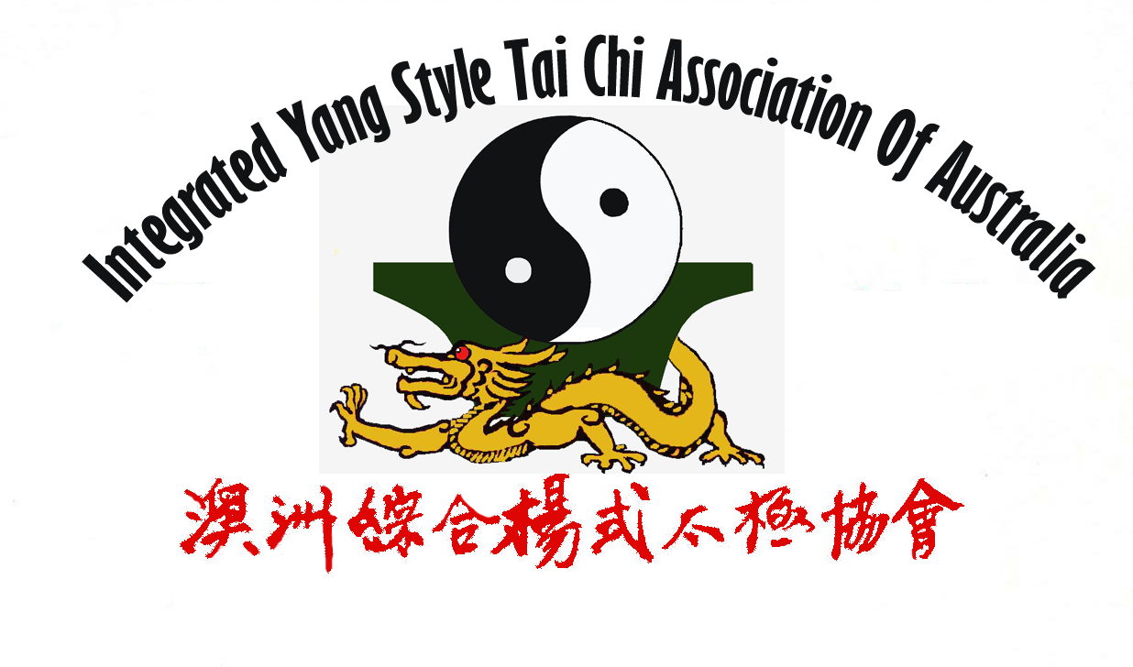
太极拳术要领
(The essences of Tai Chi practice)
综合杨式太极拳拳势
(The Patterns of Integrated Yang Style Tai Chi)
教练：方文洪医生 (外科大夫)
Master-in-Charge : Dr. B. H. Hong (Surgeon)
1 | 虚灵顶劲 Xu Ling Ding Jing
2 | 含胸拔背 Han Xiong Ba Bei
3 | 松腰松胯 Song Yao Song Kua
4 | 虚实分明 Xu Shi Fen Ming
5 | 沉肩堕肘 Chen Jian Duo Zhou
6 | 气沉丹田 Chi Chen Dan Tian
7 | 用意不用力 Yong Yi Bu Yong Li
8 | 上下相随 Shang Xia Xiang Sui
9 | 内外相合 Nei Wai Xiang He
10 | 相连不断 Xiang Lian Bu Duan
11 | 动中求静 Dong Zhong Qiu Jing

全套动作顺序及名称:
The sequence and the names of the movements used throughout the whole set:

太极拳预备式 ( Tai Chi preparation) :
手心向下↓↑,右脚分开↓↑. (Palms downward; Right foot step aside)
Shou Xing Xiang Xia, You Jiao Fen Kai

第一段 (First Part) :
(1)太极起势 ↓↑ Beginning of Tai Chi.  Tai Ji Qi Shi | (2)左揽雀尾 ↓, 堋↑,捋↓,挤↑,按↓↑  (Left grasp sparrow’s tail↓ and Ward off↑; Roll back↓; Press↑; Push↓↑)  Zuo Lan Que Wei, Pen, Lü, Ji, An
(3)右揽雀尾 ↓, 堋↑,捋↓,挤↑,按↓↑  (Right grasp sparrow’s tail ↓and Ward off↑; Roll back↓; Press↑; Push. ↓↑)  You Lan Que Wei, Pen, Lü, Ji, An | (4)单鞭 ↓↑↓↑ (Single whip.)  Dan Bian
(5)提手上势 ↓↑ (Lifting up hands)  Ti Shou Shang Shi | (6)靠 ↓↑(Lean forward)  Kao.
(7)白鹤亮翅 ↓↑ (The crane spreads its wings)  Bai He Liang Chi | (8)左搂膝拗步 ↓↑ (Left brush knee and step forward)  Zuo Lou Xi Ao Bu
(9)手挥琵琶 ↓↑ (Play the lute)  Shou Hui Pi Pa | (10)左搂膝拗步 ↓↑ (Left brush knee and step forward)  Zuo Lou Xi Ao Bu
(11)右搂膝拗步 ↓↑ (Right brush knee and step forward)  You Lou Xi Ao Bu | (12)左搂膝拗步 ↓↑ (Left brush knee and step forward)  Zuo Lou Xi Ao Bu
(13)手挥琵琶 ↓↑ (Play the lute)  Shou Hui Pi Pa | (14)左搂膝拗步 ↓↑ (Left brush knee and step forward)  Zuo Lou Xi Ao Bu
(15)进步搬拦锤↓↑↓↑ (Step forward; deflect downward and punch)  Jin Bu Ban Lan Chui | (16)如封似闭↓ (Like sealed as if closed.)  Ru Feng Shi Bi
(17)按↑ (Press)  An | (18)十字手↓↑ (Cross hands)  Shi Zi Shou
呼吸符号 (Symbols for Breathing) : 吸 ↓ ,呼 ↑ (Breathe in ↓, Breathe out ↑)

第二段 (Second Part) :
(19)抱虎归山↓↑,捋↓,挤↑,按↓↑ (Embrace the tiger and return to the mountain↓↑; Roll back↓; Press↑; Push↓↑)  Bao Hu Gui Shan, Lü, Ji, An | (20)斜单鞭↓↑↓↑ (Slanting single whip)  Xie Dan Bian
(21)肘底看锤↓↑ (Punch under the elbow)  Zhou Di Kan Chui | (22)左倒撵猴↓↑ (Left repulse the monkey)  Zuo Da Nien Hou
(23)右倒撵猴↓↑ (Right repulse the monkey)  You Da Nien Hou | (24)左倒撵猴↓↑ (Left repulse the monkey)  Zuo Da Nien Hou
(25)斜飞势↓↑ (Diagonal flying)  Xie Fei Shi | (26)提手上势↓↑ (Lifting up hands)  Ti Shou Shang Shi
(27)白鹤亮翅 ↓↑ (The white crane spreads its wings)  Bai He Lian Chi | (28)左搂膝拗步 ↓↑ (Left brush knee and step forward)  Zuo Lou Xi Ao Bu
(29)海底针↓↑ (Pick up a needle from sea bottom)  Hai Di Zhen | (30)肩通背↓↑ (Fan going through back)  Jian Tong Bei
(31)穿掌↓↑ (Pierce palm)  Chuan Zhang | (32)转身撇身锤↓↑ (Swing back and punch)  Zhuan Shen Pie Shen Chui
(33)进步搬拦锤↓↑ ↓↑ (Step forward; deflect downward and punch)  Jin Bu Ban Lan Chui | (34)上步揽雀尾↓ 堋↑捋↓挤↑按↓↑ (Step forward grasp sparrow’s tail↓; Ward off↑; Roll back↓; Press↑; Push↓↑)  Shang Bu Lan Que Wei, Pen, Lü, Ji, An
(35)单鞭↓↑ ↓↑ (Single whip)  Dan Bian | (36)云手（五次）↓↑ ↓↑ ↓↑ ↓↑ ↓ (Wave hands in cloud (Five times))  Yun Shou
(37)单鞭 ↑ (Single whips)  Dan Bian | (38)高探马↓↑ (Stand high search for horse)  Gao Tan Ma
(39)右披手↓↑ (Strike with the right hand)  You Pi Shou | (40)右分脚↓↑ (Separate the right leg)  You Fen Jiao
(41)左披手↓↑ (Strike with the left hand)  Zuo Pi shou | (42)左分脚↓↑ (Separate the left leg)  Zuo Fen Jiao
(43)转身左蹬脚↓↑ (Turn around and kick with the left heel)  Zhuan Shen Zuo Deng Jiao | (44)左搂膝拗步↓↑ (Left side brush knee and step forward)  Zuo Lou Xi Ao Bu
(45)右搂膝拗步↓↑ (Right side brush knee and step forward)  You Lou Xi Ao Bu | (46)栽锤↓↑ (Strike down with fist)  Zai Zhui
(47)挂↓↑ (Hanging up)  Gua | (48)转身撇身锤↓↑ (Swing back and punch)  Zhuan Shen Pie Shen Chui
(49)进步锤↓↑ (Step forward and punch)  Jin Bu Chui | (50)右蹬脚↓↑ (Kick with the right heel)  You Deng Jiao
(51)左伏虎↓↑ (Strike the tiger left)  Zuo fu Hu | (52)右伏虎↓↑ (Strike the tiger right)  You Fu Hu
(53)右蹬脚↓↑ (Kick with the right heel)  You Deng Jiao | (54)双风贯耳↓↑ (Strike the ears with both fists)  Shuang Fen Guan Er
(55)左蹬脚↓↑ (Kick with the left heel)  Zuo Deng Jiao | (56)转身右蹬脚↓↑ (Turn and kick with the right heel)  Zhuan Shen You Den Jiao
(57)进步搬拦锤↓↑ ↓↑ (Step forward; deflect downward and punch)  Jin Bu Ban Lan Chui | (58)如封似闭↓ (Like sealed as if closed)  Ru Feng Shi Bi
(59)按↑ (Press)  An | (60)十字手↓↑. (Cross hands)  Shi Zi Shou

第三段 (Third Part) :
(61)抱虎归山↓↑,捋↓,挤↑,按↓↑ (Embrace the tiger and return to  the mountain↓↑; Roll back↓; Press↓; Push↓↑)  Bao Hu Gui Shan, Lü, Ji, An | (62)正单鞭↓↑ ↓↑ (Single whip)  Zheng Dan Bian
(63)右野马分鬃↓↑ ((Right) Parting the wild horse’s mane)  You Ye Ma Fen Zong | (64)左野马分鬃↓↑ ((Left) Parting the wild horse’s mane)  Zuo Ye Ma Fen Zong
(65)右野马分鬃↓↑ ((Right) Parting the wild horse’s mane)  You Ye Ma fen Zong | (66)左野马分鬃↓↑((Left) Parting the wild horse’s mane)  Zuo Ye Ma Fen Zong
(67)上步揽雀尾↓ 堋↑捋↓挤↑按↓↑ (Step forward grasp sparrow’s tail↓; Ward off↑; Roll back↓; Press↑; Push↓↑)  Shang Bu Lan Que Wei, Pen, Lü, Ji, An | (68)单鞭↓↑ ↓↑ (Single whip)  Dan Bian
(69)左玉女穿梭↓↑ (Jade lady threads shuttle left)  Zuo Yu Nü Chuan Suo | (70)右玉女穿梭↓↑ (Jade lady threads shuttle right)  You Yu Nü Chuan Suo
(71)左玉女穿梭↓↑ (Jade lady threads shuttle left)  Zuo Yu Nü Chuan Suo | (72)右玉女穿梭↓↑ (Jade lady threads shuttle right)  You Yu Nü Chuan Suo
(73)左揽雀尾 ↓, 单手堋↑ (Left grasp sparrow’s tail↓ and Ward off with one hand↑)  Zo Lan Que Wei, Pen | (74)上步揽雀尾↓ 堋↑捋↓挤↑按↓↑ (Step forward grasp sparrow’s tail↓; Ward off↑; Roll back↓; Press↑;Push↓↑)  Shang Bu Lan Que Wei, Pen, Lü, Ji, An
(75)单鞭↓↑ ↓↑ (Single whip)  Dan Bian | (76)云手（五次）↓↑ ↓↑ ↓↑ ↓↑ ↓ (Wave hands in cloud (Five times))  Yun Shou
(77)单鞭 ↑ (Single whip)  Dan Bian | (78)下势 ↓↑ (Snake creep)  Xia Shi
(79)左金鸡独立↓↑ (Golden roster stands on one leg left)  Zuo Jin Ji Du Li | (80)右金鸡独立↓↑ (Golden roster stands on one leg right)  You Jin Ji Du Li
(81)左倒撵猴↓↑( Left repulse the monkey)  Zuo Dao Nien Hou | (82)右倒撵猴↓↑ (Right repulse the monkey)  You Dao Nien Hou
(83)左倒撵猴↓↑ (Left repulse the monkey)  Zuo Dao Nien Hou | (84)斜飞势↓↑( Diagonal flying)  Xie Fei Shi
(85)提手上势↓↑ (Lifting up hands)  Ti Shou Shang Shi | (86)白鹤亮翅 ↓↑ (The white crane spreads its wings)  Bai He Liang Chi
(87)左搂膝拗步 ↓↑ (Left brush knee and step forward)  Zuo Lou Xi Ao Bu | (88)海底针↓↑ (Pick up a needle from sea bottom)  Hai Di Zhen
(89)肩通背↓↑ (Fan going through back)  Jian Tong Bei | (90)穿掌↓↑ (Pierce palm)  Chuan Zhang
(91)转身撇身锤↓↑ (Swing back and punch)  Zhuan Shen Pie Shen Chui | (92)进步搬拦锤↓↑ ↓↑( Step forward; deflect downward and punch)  Jin Bu Ban Lan Chui
(93)上步揽雀尾↓ 堋↑捋↓挤↑按↓↑ (Step forward grasp sparrow’s tail ↓; Ward off↑; Roll back↓; Press↑; Push↓↑)  Shang Bu Lan Que Wei, Pen, Lü Ji, An | (94)单鞭↓↑ ↓↑ (Single whip)  Dan Bian
(95)云手（五次）↓↑ ↓↑ ↓↑ ↓↑ ↓ (Wave hands in cloud (Five times))  Yun Shou | (96)单鞭 ↑ (Single whips)  Dan Bian
(97)高探马↓↑ (Stand high search for horse)  Gao Tan Ma | (98)白蛇吐信 ↓↑ (White snake spits venom)  Bai She Tu Xing
(99)转身撇身锤↓↑( Swing back and punch)  Zhuan Shen Pie Shen Chui | (100)十字腿↓↑ (Grapple and kick)  Shi Zi Tui
(101)搂膝指裆锤↓↑ (Brush knee and punch to abdomen)  Lou Xi Zhi Dang Zhui | (102)上步揽雀尾↓ 堋↑捋↓挤↑按↓↑ (Step forward grasp sparrow’s tail↓; Ward off↑; Roll back↓; Press↑; Push↓↑)  Shang Bu Lan Que Wei, Pen, Lü, Ji, An
(103)单鞭↓↑ ↓↑ (Single whip)  Dan Bian | (104)下势 ↓↑ (Snake creep)  Xia Shi
(105)上步七星↓↑ (Step forward to 7 stars)  Shang Bu Qi Xing | (106)退步跨虎↓↑ (Step back and ride the tiger)  Tui Bu Kua Hui
(107)转身摆莲腿↓↑ (Turn body and sweep lotus with right leg)  Zhuan Shen Bai Lian Tui | (108)弯弓射虎↓↑ (Bend the bow to shot the tiger)  Wan Gong She Hu
(109)进步搬拦锤↓↑ (Step forward; deflect downward and punch)  Jin Bu Ban Lan Chui | (110)如封似闭↓ (Like sealed as if closed)  Ru Feng Shi Bi
(111)按↑ (Press)  AN | (112)十字手↓↑. (Cross hands)  Shi Zi Shou
(113)合太极 ↓↑ (Complete Tai Chi)
He Tai Ji

